Name:Alexander Thomas

Active Directory Administration
- Created and managed Active Directory objects including an Organizational Unit (LabTest2), user account (PTest2_User), and Domain Local Group (PTest2_DLG) in a Windows Server environment
- Configured group membership and verified access control by assigning users to security groups in Active Directory
- Screenshot Evidence: PartAA1.jpg (user membership in PTest2_DLG group)

File Sharing & NTFS Permissions
- Configured shared folder access on the C: drive and set share permissions to control network access
- Applied NTFS permissions to restrict file access to only the PTest2_DLG security group, demonstrating secure file-level access control
- Screenshot Evidence: PartA1.jpg (share permissions), PartA2.jpg (NTFS permissions on Test2.txt)

Printer Configuration & Security
- Installed and configured a shared network printer using a TCP/IP port and Canon printer driver
- Configured printer sharing and assigned security permissions, granting Manage Documents rights to a security group
- Screenshot Evidence: PartB1.jpg (Sharing tab), PartB2.jpg (TCP/IP port settings), PartB3.jpg (Security permissions)

DHCP Configuration
- Created and configured a DHCP scope with defined IP range, subnet mask, default gateway, and DNS settings
- Implemented a DHCP reservation using a MAC address to ensure consistent IP assignment for a server
- Screenshot Evidence: PartC1.jpg (scope configuration), PartC2.jpg (reservation details including MAC address)

PowerShell Automation & Reporting
- Developed a PowerShell script using Get-Printer and Format-Table to generate a printer inventory report
- Automated directory creation, system data collection (server name, date, logged-in user), and export to a log file
- Generated structured administrative reports with execution confirmation output for validation
- Screenshot Evidence: PartD1.jpg (script execution in PowerShell ISE), PartD2.jpg (generated report output)

Part AA1
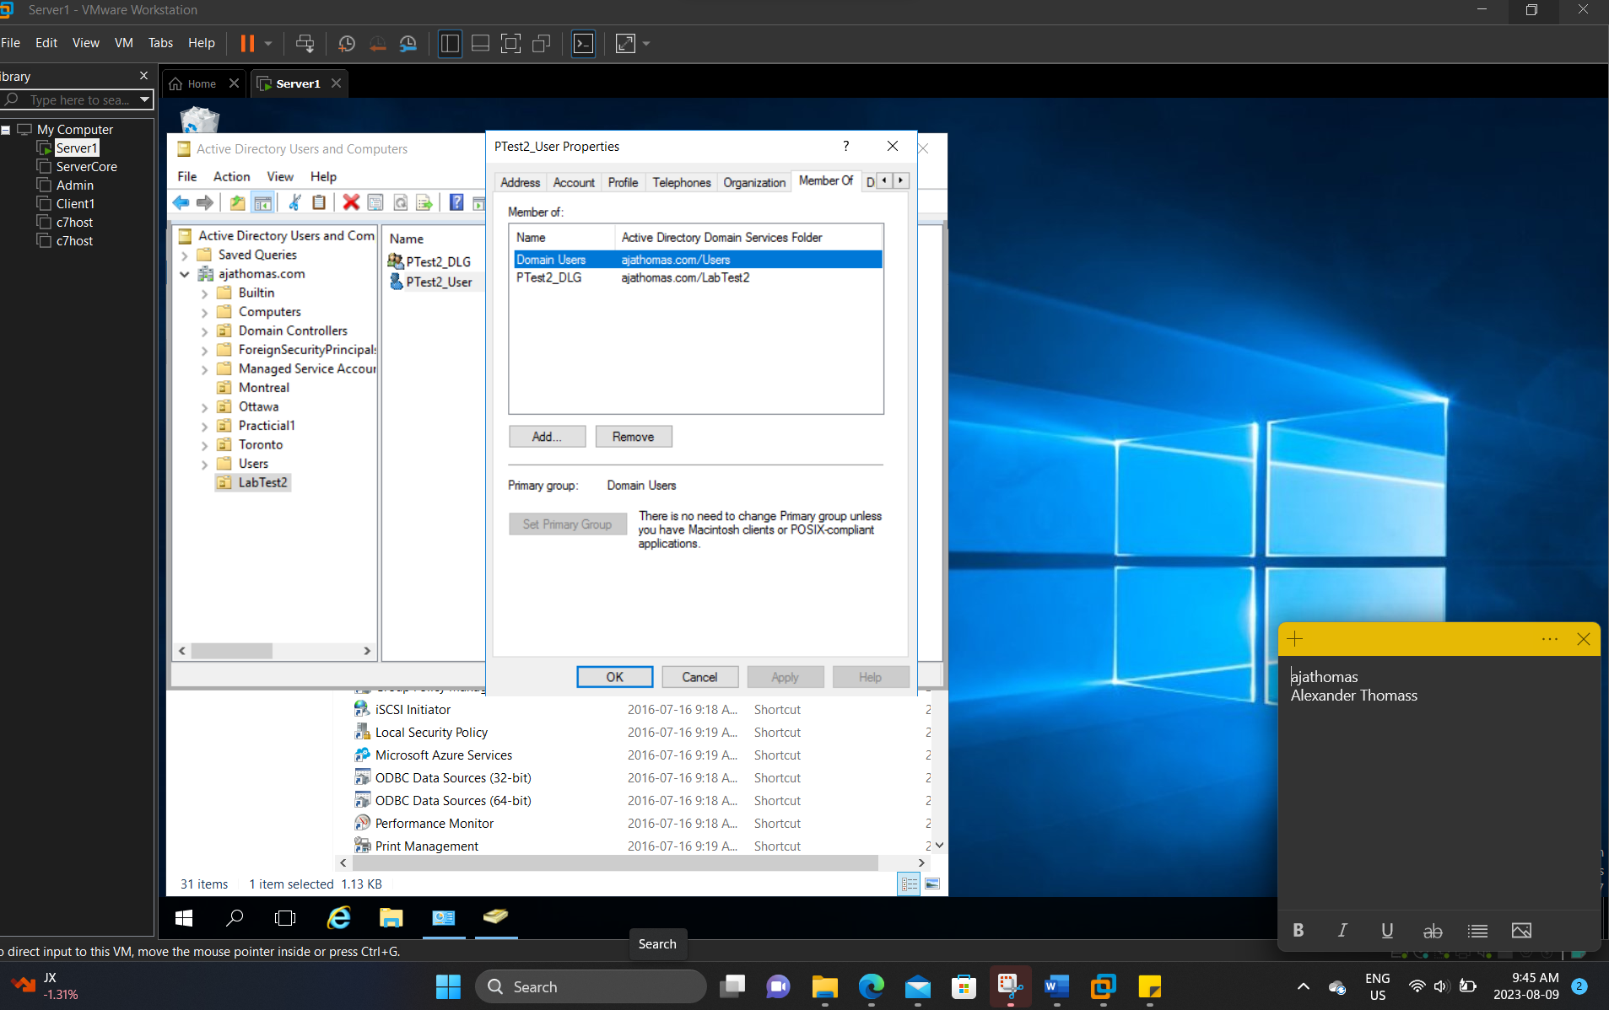
PartA1
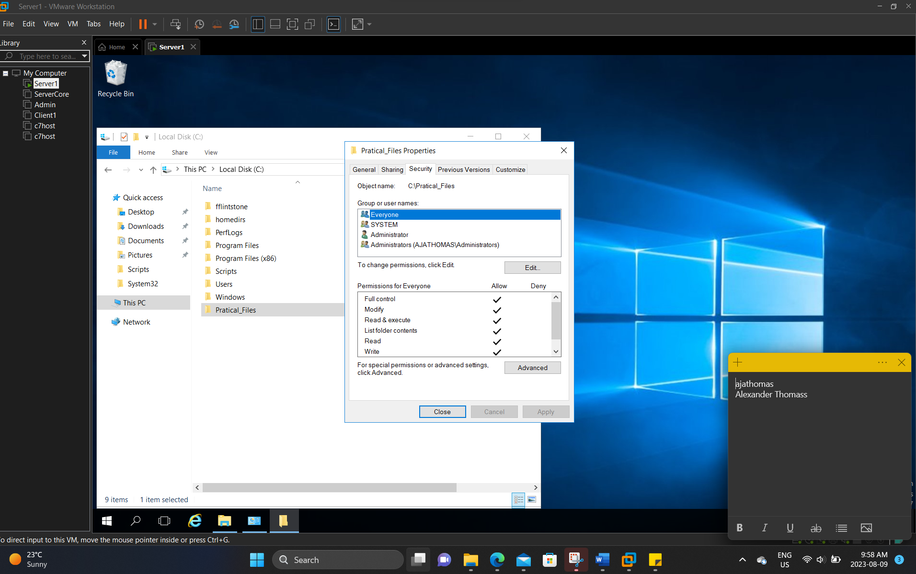
PartA2
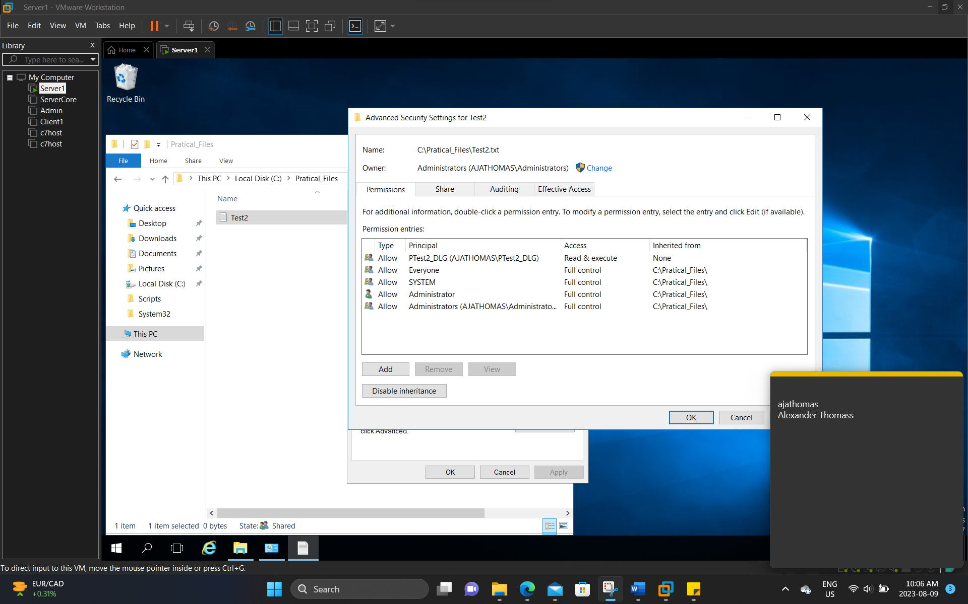

PartB1
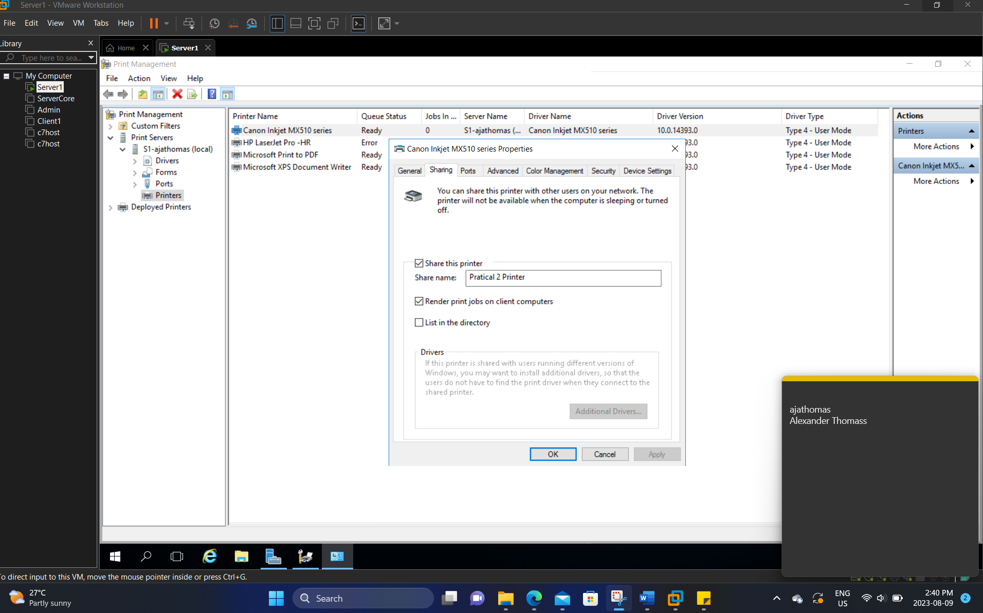
PartB2
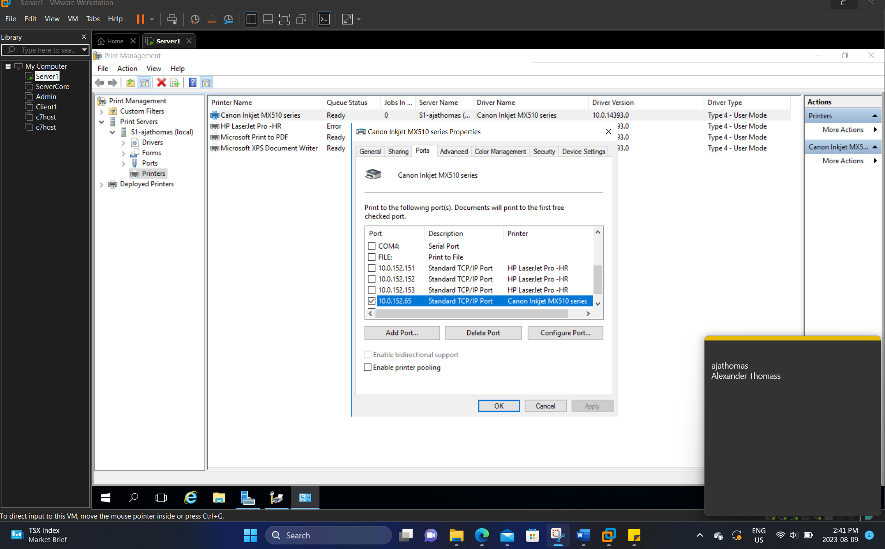
PartB3
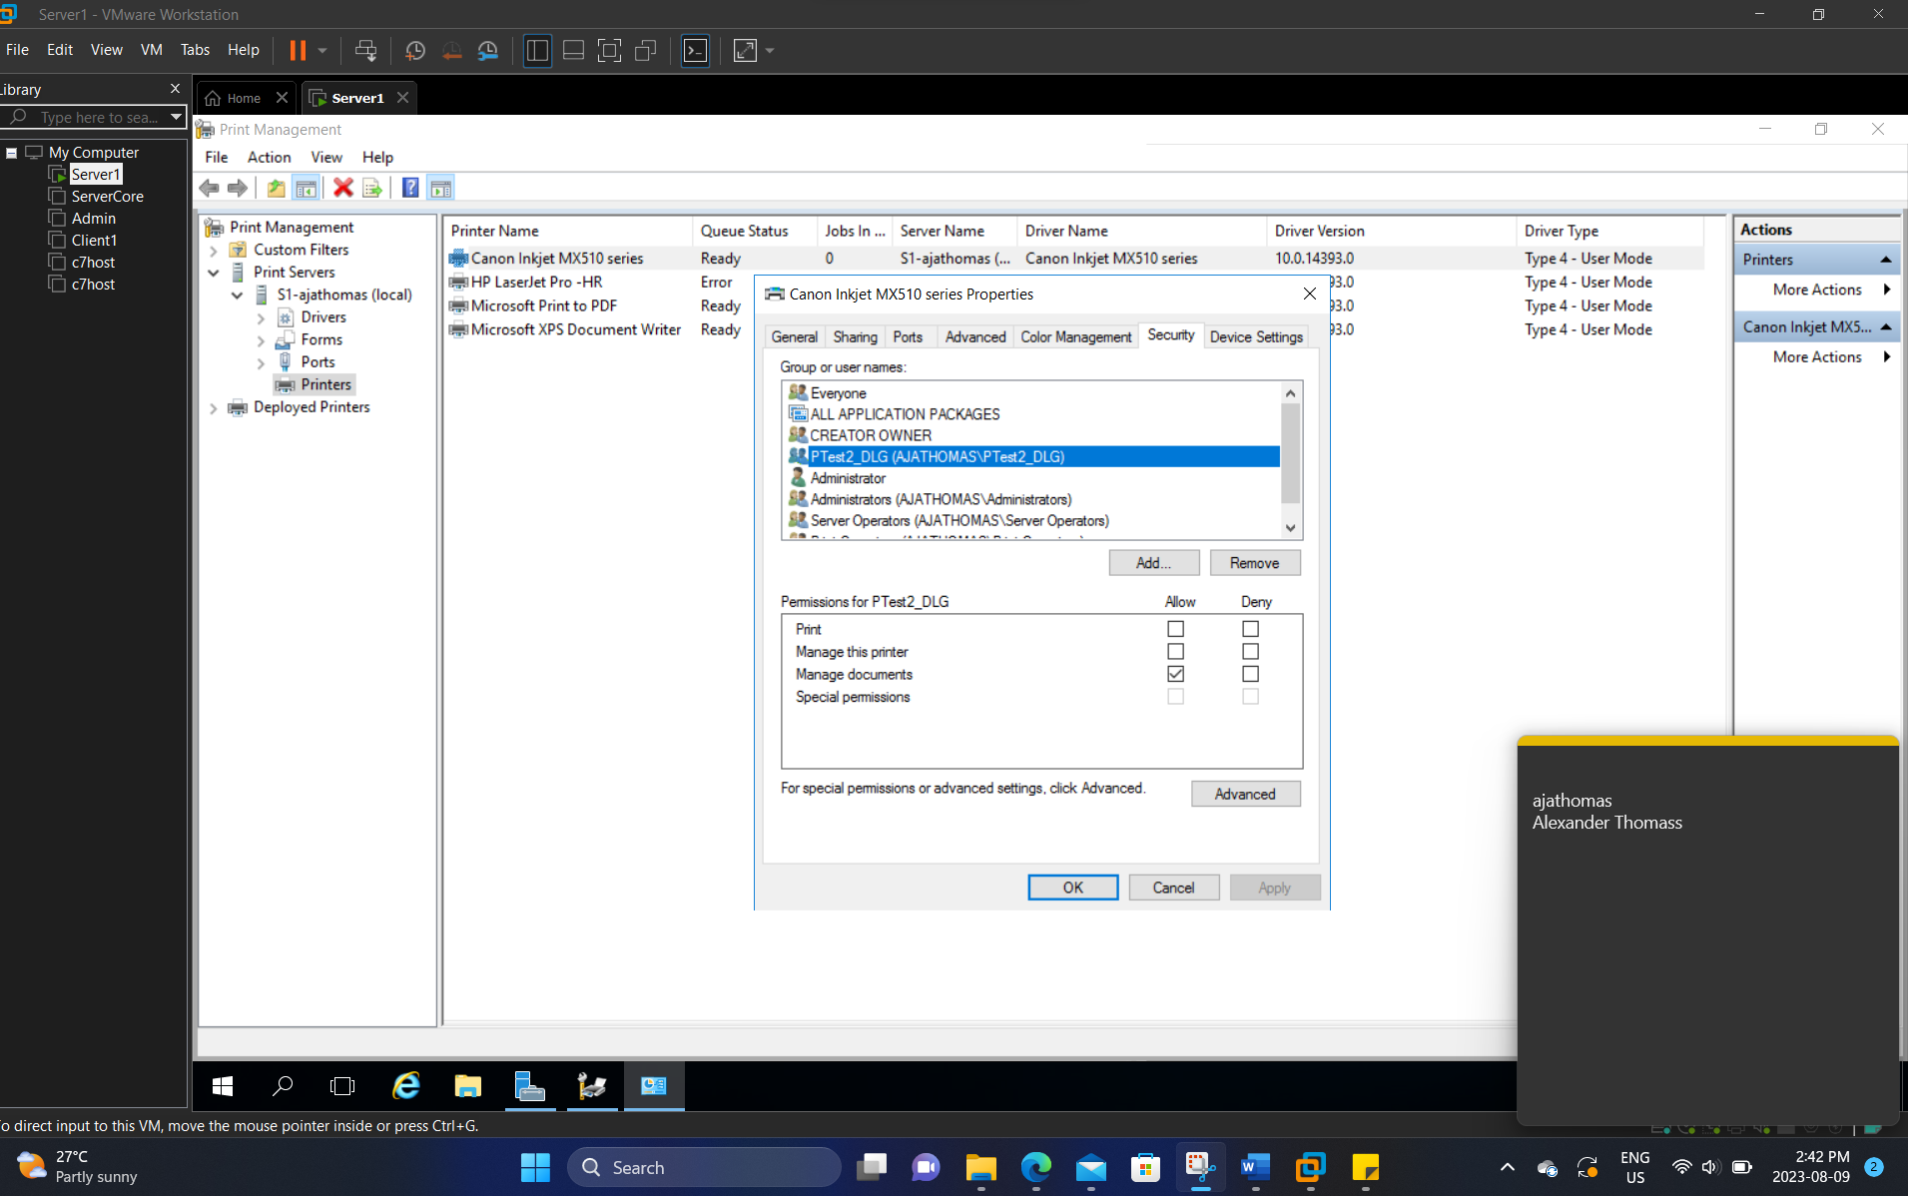
PartC1
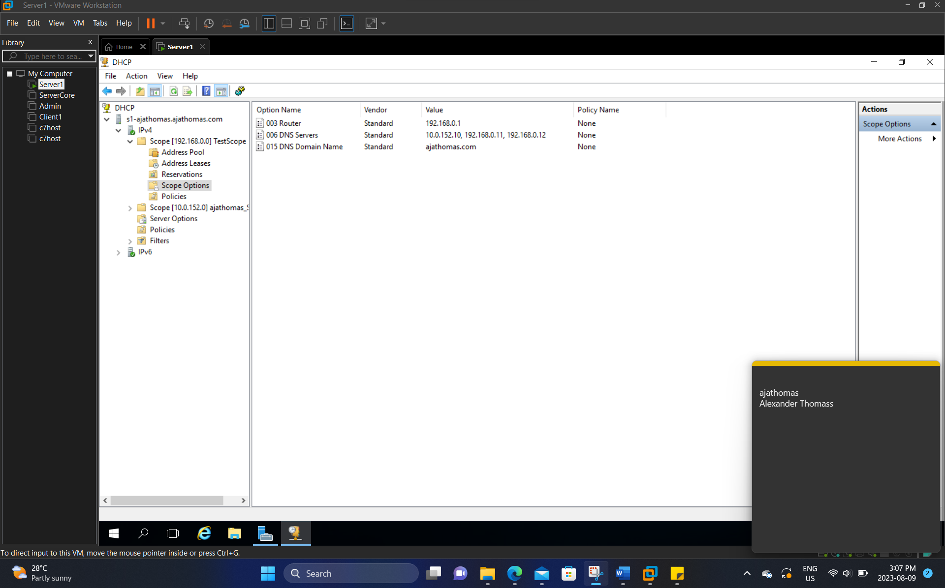

PartC2
MAC address:00:00X29:5a:92:c3
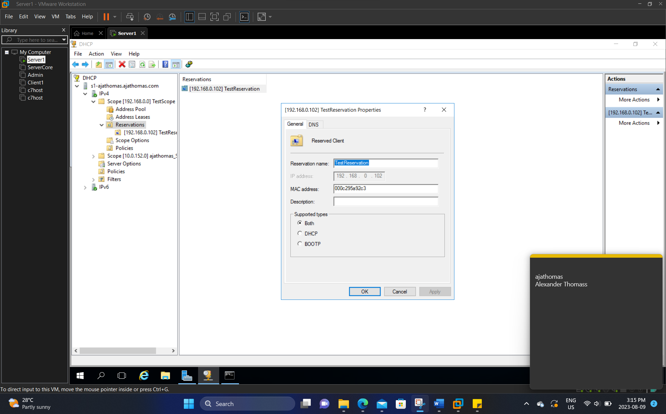

PartD1
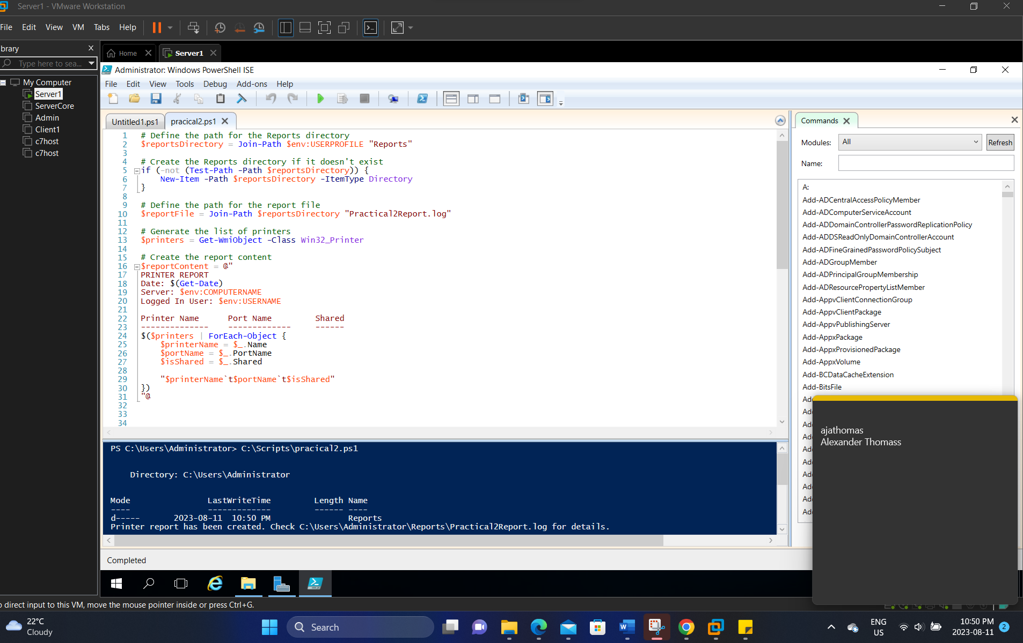
PartD2
